# Intermediate Spreadsheets.

## 1. [1.] Logical operations [mantıksal işlemler]

In this chapter you'll learn to work with logical values, namely TRUE and FALSE. [Bu bölümde DOĞRU ve YANLIŞ gibi mantıksal değerlerle çalışmayı öğreneceksiniz.]

## 2. [2.] The opposite of true [doğrunun tam tersi]

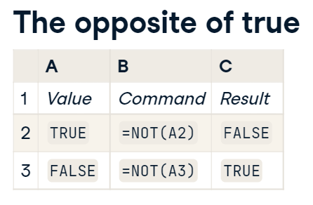

The simplest logical operation is to change a TRUE value to FALSE, or FALSE to TRUE. [En basit mantıksal işlem, DOĞRU değerini YANLIŞ olarak veya YANLIŞ değerini DOĞRU olarak değiştirmektir.] This is done using the NOT() function. [Bu, NOT() işlevi kullanılarak yapılır.] Just as you would say in English, FALSE is NOT TRUE and TRUE is NOT FALSE. [Tıpkı İngilizcede söyleyeceğiniz gibi, YANLIŞ DOĞRU DEĞİLDİR ve DOĞRU YANLIŞ DEĞİLDİR.]

## 3. [3.] This and that [Bu ve şu]

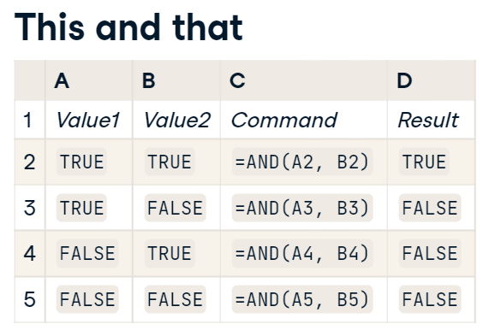

There are two logical operations that accept multiple inputs. [Birden çok girişi kabul eden iki mantıksal işlem vardır.] The AND() function returns TRUE when all of its inputs are TRUE, and FALSE when any of its inputs are FALSE. [AND() işlevi, tüm girişleri DOĞRU olduğunda DOĞRU, girişlerinden herhangi biri YANLIŞ olduğunda YANLIŞ değerini döndürür.]

## 4. [4.] One or the other [Biri veya diğeri]

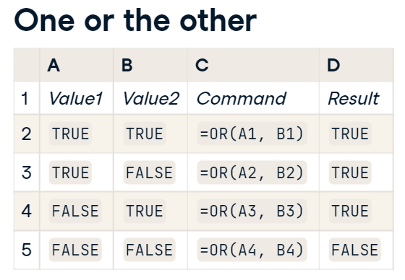

The OR() function also accepts multiple inputs. [VEYA() işlevi ayrıca birden çok girişi kabul eder.] It returns TRUE when any of its inputs are TRUE, and FALSE when all of its inputs are FALSE. [Girişlerinden herhangi biri DOĞRU olduğunda DOĞRU, tüm girişleri YANLIŞ olduğunda YANLIŞ döndürür.]

## 5. [5.] Summary [özet]

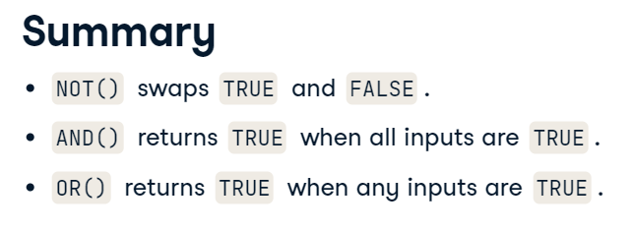

To summarize, there are three logical operations. [Özetlemek gerekirse, üç mantıksal işlem vardır.] NOT() turns TRUE into FALSE and FALSE into TRUE. [NOT() DOĞRU'yu YANLIŞ'a ve YANLIŞ'ı DOĞRU'ya dönüştürür.] AND() returns TRUE when all its inputs are TRUE, and OR() returns TRUE when any of its inputs are TRUE. [AND(), tüm girdileri DOĞRU olduğunda DOĞRU döndürür ve VEYA(), girişlerinden herhangi biri DOĞRU olduğunda DOĞRU değerini döndürür.]

## 6. [6.] Let's get logical! [Mantıklı olalım!]

Let's get logical! [Mantıklı olalım!]

#### (1) Logical operations are hard... NOT!

In this chapter, you will explore logical operations using **[unemployment data from 1972](https://www.rdocumentation.org/packages/Ecdat/topics/Benefits" \t "_blank)**. Each row corresponds to a woman was made unemployed because their seasonal job ended.

The simplest logical operation is [**NOT()**](https://support.google.com/docs/answer/3093305), which negates its input. That is, NOT(TRUE) is FALSE and NOT(FALSE) is TRUE.

Logical operations are useful for filtering datasets: you can keep only the rows where some condition is TRUE. Data filtering can be done using [**FILTER()**](https://support.google.com/docs/answer/3093197), which takes two arguments. The first argument is the range of the data that you want to filter, and the second argument is the range of the logical condition to filter on.

For example, if the data (not including the header row) is in A2:E10, and the final column contains the logical condition to filter on, you would type =FILTER(A2:E10, E2:E10).

##### Instructions

* In column H, negate the "Is non-white?" column to find women who are white.
* In cell A28, define a filter on the whole dataset from A2 to H25, using the values in column H as the condition to filter on.

#### (2) AND now for something completely different

Sometimes you want to know if several logical conditions are all true at the same time. For this you can use the [**AND()**](https://support.google.com/docs/answer/3093301) function.

AND(TRUE, TRUE, TRUE) returns TRUE, since all the inputs are TRUE. AND(TRUE, FALSE, TRUE) returns false, since the second input is not TRUE.

##### Instructions

* In column H, find the women who are married and have kids, but not young kids.
* In cell A28, define a filter to return only the rows where column H is TRUE.

#### (3) Yea OR nay

The third logical operator is [**OR()**](https://support.google.com/docs/answer/7013690). This returns TRUE when any of its inputs is TRUE.

For example, OR(FALSE, TRUE, FALSE) returns TRUE since the second input is TRUE, but OR(FALSE, FALSE, FALSE) returns FALSE since all its inputs are FALSE.

##### Instructions

* In column H, find women who are white or have over 12 years of school
* In column I, find women who match the previous condition and get unemployment insurance benefits.
* In cell A28, define a filter to return only the rows that match conditions in column I.